Assignment Submission

Course Code: 23CS2048
Course Title: Web Technology
Date: 16.07.2026

Name: pulagurla sairam
Regno:urk24cs9064

Screenshot of the Full Program

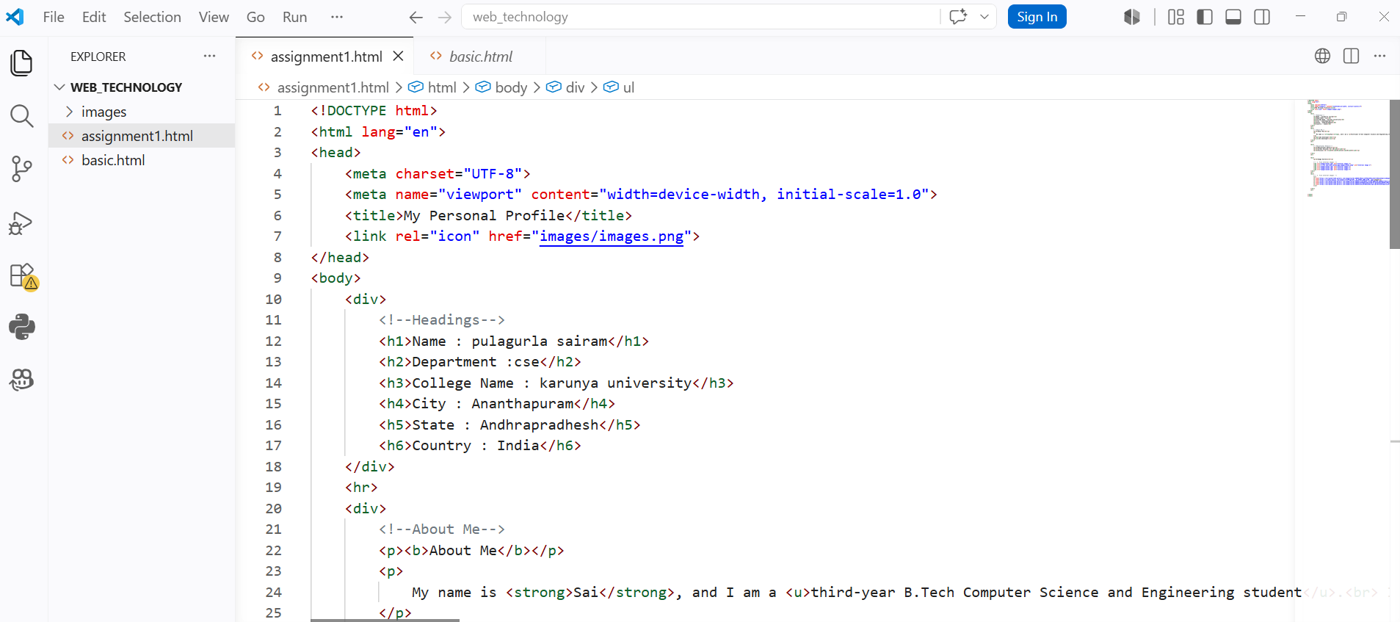

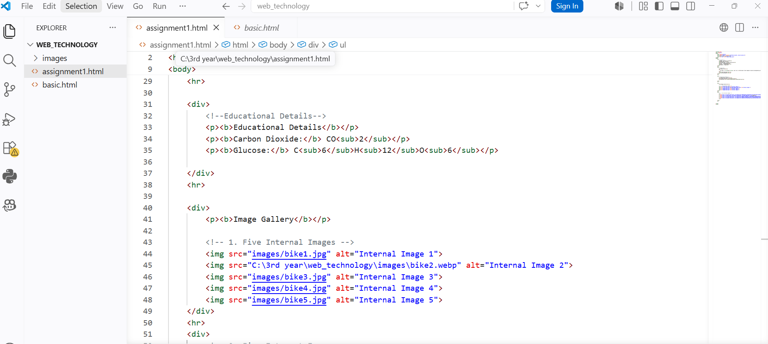

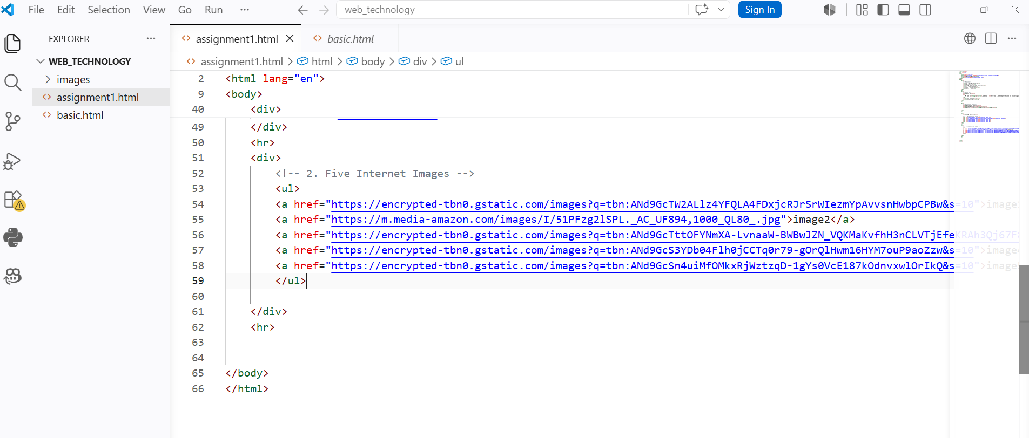

Output Screenshot

